The Arctic resource frontier as an interdisciplinary challenge
A one-day research workshop on arctic extractive industries,
September 6, 2016, Moesgård, Aarhus university.

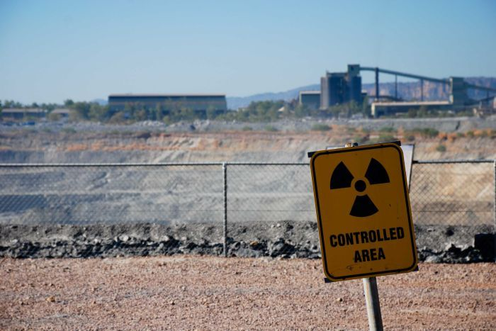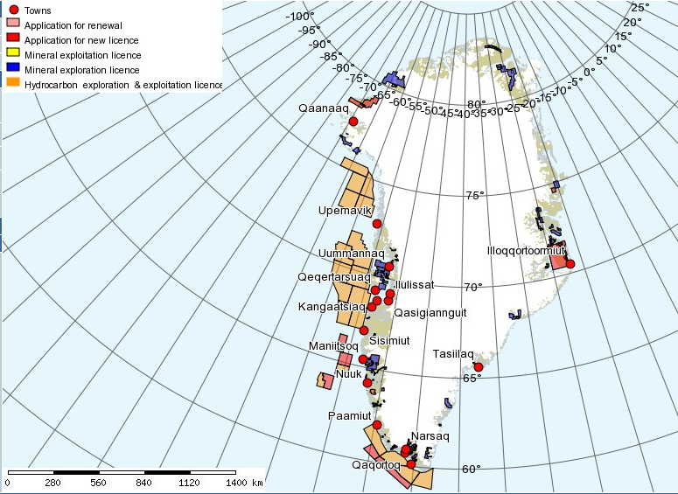

Climate change opens new passageways to the Arctic and non-renewable resource extraction. Thus exploration, development, extraction, processing, shipping, sub-contracting and services are generating an increasing interest among foreign governments and multinationals on the global market. This renewed interest and accessibility influences geopolitical balances and makes the Arctic an upcoming resource frontier for interdisciplinary inquiries. This is especially the case with mining and hydrocarbon exploration as industries with the potential to alter and affect all aspects of human and nonhuman life in the arctic environment.

At the first workshop of the new Extractive Industries Group based at ARC we were pleased to welcome Gunhild Hoogensen Gjørv, Professor in International Relations at the University of Tromsø (UiT), for a one-day workshop on the key interdisciplinary challenges and human security issues associated with resource extraction in the Arctic. Gunhild’s expertise concerns the impacts extractive industries upon Arctic peoples and her talk provided a stimulating and insightful commentary on contemporary security issues at stake in the debate over arctic resource frontiers.

The Extractive Industries Group is founded by Pelle Tejsner and Vladimir Pacho Cuevo from the Arctic Research Center (ARC), and includes colleagues from Aarhus University Research on the Anthropocene (AURA), Danish Center for Environment and Energy (DCE) and Aarhus Institute for Advanced Studies (AIAS).
workshop.

